Project R System Documentation

Naming Convention

Variable names are camelCase (lowercase on the first letter of the first word, uppercase on the first letter of the rest of the words)

Method/function names are MixedCase (uppercase on the first letter of all words)

Scenes

|  |  |
| --- | --- |
| **Scene Name** | **Description** |
| Main Menu.unity | Main menu |
| Dungeon.unity | Dungeon themed first level |
| Forest.unity | Forest themed second level |
| Town.unity | Town themed third level |

Scripts

|  |  |
| --- | --- |
| **Script Name** | **Description** |
| AddHealth.cs | Restores health |
| Attack_Cone.cs | Activates turret monsters when the player is within its attack range |
| attackTrigger.cs | Behaviors for players’ attacks |
| BigBossTreeScript.cs | Second boss behavior |
| BossDoor.cs | Closes the door in the first boss monster room |
| Bullet.cs | Behavior for turrets’ projectiles |
| CameraFollow.cs | Makes camera follow the player |
| CameraScript.cs | Offset the camera |
| ChangeCameraSize.cs | Change the size of camera in first boss monster room |
| ColorChange.cs | Continuously change color on main menu title and the congratulations message in the last level |
| DestroyOnPlayerContact.cs | Destroy objects that come in contact with player |
| EnemyAIScript.cs | AI for slime |
| EnergyBall.cs | Behavior for player’s magic projectile |
| FallingRockScript.cs | Second stage apple falling script |
| GroundCheck.cs | Checking if player is on the ground |
| HUD.cs | Updates heart graphics according to health |
| InputManager.cs | Takes in keyboard inputs and returns boolean value |
| KeepOldHealth.cs | Save health value between scenes |
| LevelControl.cs | Loads different scenes |
| MainMenu.cs | Functionality for main menu buttons |
| PauseMenu.cs | Functionality for pause menu buttons |
| Player.cs | Player physics and stats |
| playerAttack.cs | Weapon collision and attack animation |
| Slime.cs | Slime physics and stats |
| SlimeBossAI.cs | Slime boss patterns |
| Spikes.cs | Spike damage & knockback on player |
| TurretAI.cs | Turret AI |
| WeaponSwitching.cs | Functionality for weapon switching |

Variables and methods used are explained within each script.

Hierarchy

Hierarchy contains information of objects used in each scene.

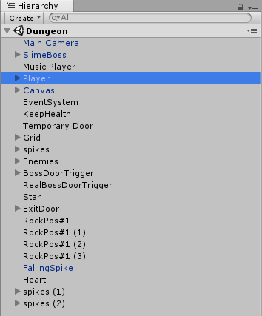

Selecting an object shows the object’s children object and displays the object within the scene. You can resize the object using the scene window or check where the collision detectors are.

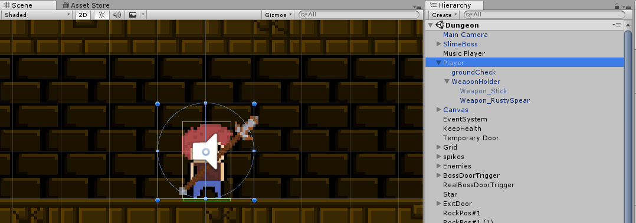

Selecting an object in Hierarchy window also opens Inspector window for the object. In Inspector, you can look at the object’s properties, animations, scripts, etc. being used. You can change values of the properties using Inspector.

